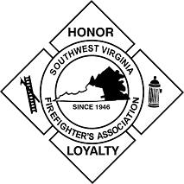
Southwest Virginia Firefighters Association
We Protect Southwest Virginia

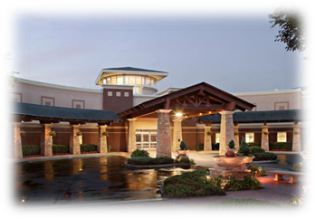
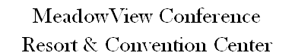

MeadowView Conference Resort & Convention Center
1901 Meadowview Parkway
Kingsport, Tennessee 37660

Hotel Contact:

Please make your reservations with

Mary Alice Masuta
at
maryalice.masuta@marriott.com

Monday – Friday 7:30 am – 4:30 pm

Phone: 423-578-6550
Fax: 423-578-6650

$106.00 / night

Double or King room
Rate is based on Double Occupancy

Please advise them that you are with the Southwest Virginia Firefighter’s Association.

All reservations need to be under the name of the person staying in the room.

